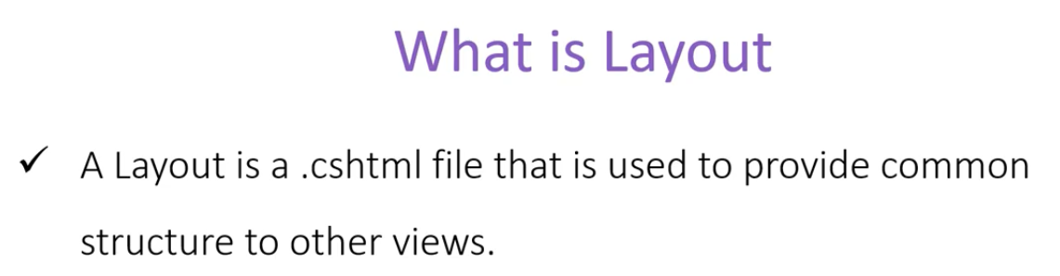

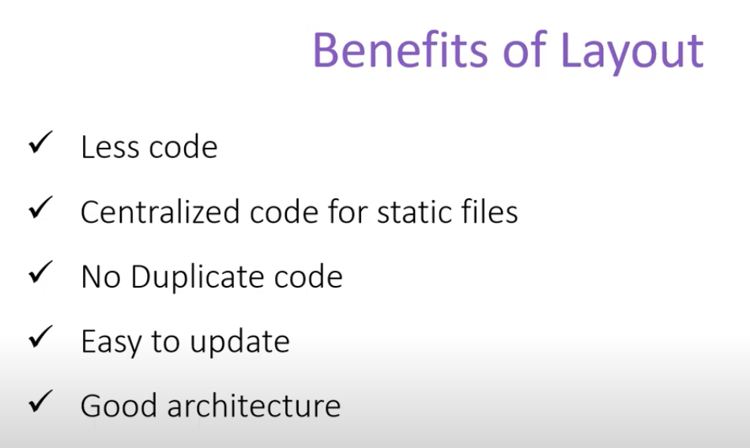

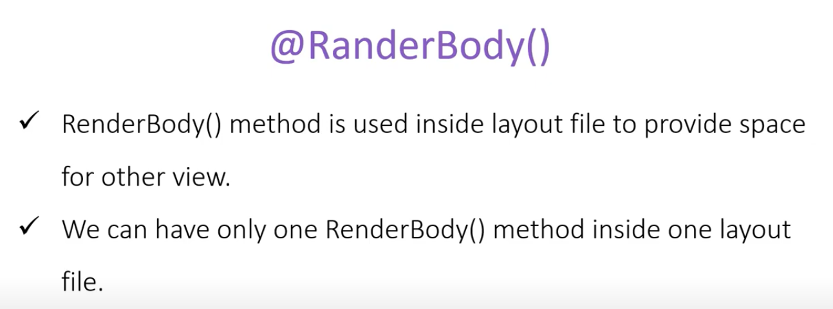

It is a naming convention in asp.net core application to start the name of a view with an underscore ( **_** ) if it is common to the whole application.

This is an example of adding a layout to a page

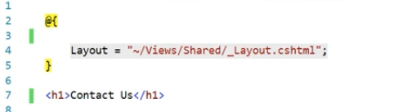

One Small issue with using this layout section is that the javascript files are available usually at the bottom of the file. In case we want to run for example a Jquary code inside the renderbody() method, it will not run since at that point the source file reference will not be available at that point, its referenced at the botton. To solve this problem we need rendersection(). We can also use the rendersectionAsync() as well. It takes two parameter, name and required. We can make required false to make this rendersection optional.

